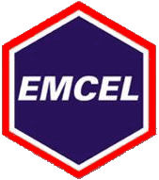**Activated Carbon Types**

We offer a variety of carbon types and grades for most odour removal applications. Certain types of carbon are best suited to applications requiring a specific efficiency or where a low pressure drop is specified.

Shown below are the most popular types of activated carbon together with examples of the applications for which they are used. While the range of applications covered is extensive, this is by no means a complete, definitive list – sometimes special applications need special carbon grades. Please contact our technical sales team for more information or if you would like a quotation for an odour filter.

**Acid Gases, Sewage Odours &**

**Atmospheric Pollutants**

Our **Tank Breather** filters are suited to a number of applications, including septic tanks

and storage or process tanks containing sewage sludge or odorous chemicals.

Our ***Sonoxcarb*** units have proved very effective at removing atmospheric pollution gases at

a number of museums, galleries

and archive stores.

**General/Organic Odours**

We would usually recommend

an **Activ-V** carbon filter unit for applications in offices, hospitals, airports and hotels, or a **Maxicarb** unit for use in laboratories,

research facilities and chemical process plants.

**Stronger General Odours**

Our **Maxicarb** and **Katercarb** use a high activity carbon for high odour levels as found in hospitals, industrial applications as well as cooking odours from restaurants, takeaways and food factories.

**Arsine & Phosphine**

For pyrophoric hydrides, such

as arsine and phosphine, as often emitted from semiconductor production, we recommend the use of a sealed

**Chemicarb** filter with a specially-impregnated

grade

[**www.emcelfilters.co.uk**](http://www.emcelfilters.co.uk/)

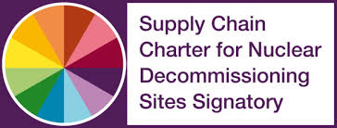[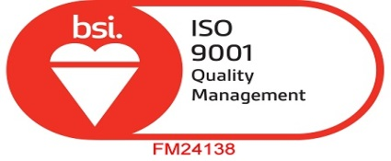](http://www.emcelfilters.co.uk/wp-content/uploads/2015/07/BSI-Cert-FM-24138-2015.pdf)